**Client’s Trading Behavior Analytics**

**Overview**

The app will contain a page where the client can see the past trading patterns, and identify strong and weak traits of client’s trading behavior, in a given time period. In the service console page, there will be a menu named “Trading Behavior Analytics”, inside this menu there will be 4 tabs named:

1. Trading Analytics Summary
2. Stock wise Gain/Loss Summary
3. Gain/ (Loss) Heatmap
4. Gain/Loss Trend.

Trading Analytics Summary tab will show one line summaries of the client’s overall trading patterns in the given time period, such as Total Gain/Loss, Gain/Loss Percentage etc. The tab will also contain a bar chart and a pie chart showing number of gaining and losing trades of the client.

Stocks Gain/Loss Summary tab will show the stocks the client had in the portfolio in the given data range, and stock wise gain / loss. Additionally the tab will contain a diverging bar chart showing stockwise net gain, stocks sorted according to net gain.

Gain/(Loss) Heatmap will show a heatmap calendar, with dates colored as green or red, indicating gain or loss in that particular day.

Gain/Loss Charts tab will contain a table, showing datewise Realized and Unrealized gain. And two line charts, one showing realized and unrealized gain separately, and another line chart showing realized+unrealized gain over the time period.

**Date range can be selected by the user, with Start and End date calendar input at the top of the window.

**Calculations**

The clients will select a specific “Date Range” in the interface, and all calculations will be done in the given date range for that particular client.

**Primary Data for calculations**

The primary data must contain datewise fields for the specific client as below:  
Date, Code, Stock, free Quantity, immature quantity, Avg Cost Price, Market Price, BuyQuantity, BuyAmount, SellQuantity, SellAmount, SellCommission, Lag.avg_Price(Previous Day’s Avg Cost Price); (For all the working days in the given date range)

Additional fields to be calculated in the primary data:  
1. Gain_Loss_SELLING = WHEN SellAmount > 0 THEN (SellAmount-SellCommission) - (SellQty*Lag.avg_Price), where SellAmount > 0

2. Gain_SELLING = WHEN ((SellAmount-SellCommissionAmount) - (SellQty*Lag.avg_Price)) > 0 THEN  
 ((SellAmount-SellCommissionAmount) - (SellQty*Lag.avg_Price))  
  
3. Loss_SELLING = WHEN ((SellAmount-SellCommissionAmount) - (SellQty*Lag.avg_Price)) < 0 THEN  
 ((SellAmount-SellCommissionAmount) - (SellQty*Lag.avg_Price))  
  
4. Cost_Percent_Gain_SELLING = WHEN ((SellAmount-SellCommissionAmount) - (SellQty*Lag.avg_Price)) > 0 AND (SellQty*Lag.avg_Price) > 0 THEN   
(((SellAmount-SellCommissionAmount) - (SellQty*Lag.avg_Price)) / (SellQty*Lag.avg_Price))   
  
5. Cost_Percent_Loss_SELLING = WHEN ((SellAmount-SellCommissionAmount) - (SellQty*Lag.avg_Price)) < 0 AND (SellQty*Lag.avg_Price) > 0 THEN (((SellAmount-SellCommissionAmount) - (SellQty*Lag.avg_Price)) / (SellQty*Lag.avg_Price))   
  
6. Gain_HOLDING = WHEN ((free_Qty + um_Qty)*market_price) - ((free_Qty + um_Qty)*avg_price) > 0 THEN ((free_Qty + um_Qty)*market_price) - ((free_Qty + um_Qty)*avg_price)   
  
7. Loss_HOLDING = WHEN ((free_Qty + um_Qty)*market_price) - ((free_Qty + um_Qty)*avg_price) < 0 THEN ((free_Qty + um_Qty)*market_price) - ((free_Qty + um_Qty)*avg_price)

**1.** **Summary Table**

All the fields in this table will be calculated from the ‘Primary Data’.

1. Number_of_Gaining_Trades = COUNT(Gain_SELLING > 0)  
  
2. Number_of_Losing_Trades = COUNT(Loss_SELLING < 0)  
  
3. Percentage_of_Gaining_Trades = Number_of_Gaining_Trades /   
 (Number_of_Gaining_Trades + Number_of_Losing_Trades)

4. Percentage_of_Losing_Trades = Number_of_Losing_Trades /   
 (Number_of_Gaining_Trades + Number_of_Losing_Trades)  
  
5. Total_Gain = sum(Gain_SELLING)  
  
6. Total_Loss = sum(Loss_SELLING)  
  
7. Net_Gain = Total_Gain + Total_Loss,  
  
8. Average_Gain_Per_Gain_Trade = Total_Gain / Number_of_Gaining_Trades  
  
9. Average_Loss_Per_Losing_Trade = Total_Loss / Number_of_Losing_Trades  
  
10. Max_Gain_in_Single_Trade = max(Gain_SELLING)  
  
11. Max_Loss_in_Single_Trade = min(Loss_SELLING)  
  
12. Average_Gain_Percentage_of_Cost_Value_Per_Trade = mean(Cost_Percent_Gain_SELLING)

13. Average_Loss_Percentage_of_Cost_Value_Per_Trade = mean(Cost_Percent_Loss_SELLING)

**Stock Wise Average Table**Primary Data > Group by(Stock), then calculate the following fields:

1. Days_Gain_Holding = COUNT(Gain_HOLDING > 0)

2. Days_Loss_Holding = COUNT(Loss_HOLDING < 0)

3. Days_Hold = Days_Gain_Holding + Days_Loss_Holding

4. Total_Gain = sum(Gain_SELLING)

5. Total_Loss = sum(Loss_SELLING)

6. Net_Gain = Total_Gain + Total_Loss

7. Average_Gain_Percentage_of_Cost_Value = mean(Cost_Percent_Gain_SELLING)

8. Average_Loss_Percentage_of_Cost_Value = mean(Cost_Percent_Loss_SELLING)

**Overall Per Stock Average Table**

From ‘Stock Wise Average Table‘, calculate the following fields:

1. Average_Gain_Holding_Days_Per_Stock = mean(Days_Gain_Holding)

2. Average_Loss_Holding_Days_Per_Stock = mean(Days_Loss_Holding)

3. Median_Gain_Holding_Days_Per_Stock = median(Days_Gain_Holding)

4. Median_Loss_Holding_Days_Per_Stock = median(Days_Loss_Holding)

5. Average_Gain_Per_Stock = mean(Total_Gain)

6. Average_Loss_Per_Stock = mean(Total_Loss)

7. Max_Gain_in_Single_Stock = max(Total_Gain)

8. Max_Loss_in_Single_Stock = min(Total_Loss)

Then, add these 8 fields in the ‘Summary Table’.

**2.** **Stock wise Gain/Loss Table**

From ‘Stock Wise Average Table‘, keep the following fields that are already calculated:  
Code, Stock, Total_Gain, Total_Loss, Net_Gain, Average_Gain_Percentage_of_Cost_Value, Average_Loss_Percentage_of_Cost_Value

**3.** **Daily Gain/Loss Table for Heatmap**

Primary Data > Group by(Date), then calculate the following fields:

1. Total_Gain = sum(Gain_SELLING)

2. Total_Loss = sum(Loss_SELLING)

3. Net_Gain = Total_Gain + Total_Loss

**4.** **Realized and Unrealized Gain Table**

This is a separate table, with fields investor_Code, Date, Realized_Gain, Unrealized_Gain, TWRR(Time Weighted Rate of return) in the given date range. This table will be used in charts in Tab 1 and Tab 2.

**User Interface**

There will be 3 Tabs in the ‘Trading Analytics’ page in the Console. The tabular contents in the 3 tabs are as below.

**Tab 1 : Trading Analytics Summary**

This tab will show a table as below, where the ‘Value’ column will show values from ‘*Summary Table*’. The Description column will be hidden, and the client will be able to see the description by clicking on a small ‘i’ icon placed on each row of the Attribute column.

|  |  |  |  |
| --- | --- | --- | --- |
| **Attribute** | **Value** | **Description** | **Field from Calculation to show in value column** |
| Number of Gaining Trades |  | Total Number of trades that resulted in Positive Realized Gain | Number_of_Gaining_Trades |
| Number of Losing Trades |  | Total Number of trades that resulted in Negative Realized Gain | Number_of_Losing_Trades |
| Percentage of Gaining Trades |  | Percentage of Gaining trades out of total number of trades | Percentage_of_Gaining_Trades |
| Percentage of Losing Trades |  | Percentage of Losing trades out of total number of trades | Percentage_of_Losing_Trades |
| Total Gain |  | Total Realized Gain from trading | Total_Gain |
| Total Loss |  | Total Realized Loss from trading | Total_Loss |
| Net Gain /(Loss) |  | Total Realized Gain / (Loss) from trading | Net_Gain |
| Average Gain Per Trade |  | Average Gain in Gaining Trades | Average_Gain_Per_Gain_Trade |
| Average Loss Per Trade |  | Average Loss in Losing Trades | Average_Loss_Per_Losing_Trade |
| Max Gain in a Single Trade |  | Maximum Gain achieved in a single trade | Max_Gain_in_Single_Trade |
| Max Loss in a Single Trade |  | Maximum Loss achieved in a single trade | Max_Loss_in_Single_Trade |
| Average Gain % Per Trade |  | Average Gain in percentage of cost value per gaining trade | Average_Gain_Percentage_of_Cost_Value_Per_Trade |
| Average Loss % Per Trade |  | Average Loss in percentage of cost value per losing trade | Average_Loss_Percentage_of_Cost_Value_Per_Trade |
| Average Gain Position per Stock in Days |  | On average, how many days the client holds a stock in gaining position, i.e. market value > cost value | Average_Gain_Holding_Days_Per_Stock |
| Average Loss Position per Stock in Days |  | On average, how many days the client holds a stock in losing position, i.e. market value < cost value | Average_Loss_Holding_Days_Per_Stock |
| Median Gain Position per Stock in Days |  | Holding days of 50% of Gaining stocks | Median_Gain_Holding_Days_Per_Stock |
| Median Loss Position per Stock in Days |  | Holding days of 50% of Losing stocks | Median_Loss_Holding_Days_Per_Stock |
| Average Gain Per Stock |  | Average Gain per stock | Average_Gain_Per_Stock |
| Average Loss Per Stock |  | Average Loss per stock | Average_Loss_Per_Stock |
| Max Gain in a Single Stock |  | Maximum Total Realized Gain in a single Stock | Max_Gain_in_Single_Stock |
| Max Loss in a Single Stock |  | Maximum Total Realized Loss in a single Stock | Max_Loss_in_Single_Stock |
| TWRR (Time Weighted Rate of Return) |  | TWRR YTD, till last date in the Date Range | TWRR at Last date of the Date Range |

The tab will also contain two charts as per below example. The bar chart shows number of gaining trades and nuber of losing trades. And the pie chart shows the same data in percentage. With Green color indicating Gain trades, and Red color indicating Losing trades.

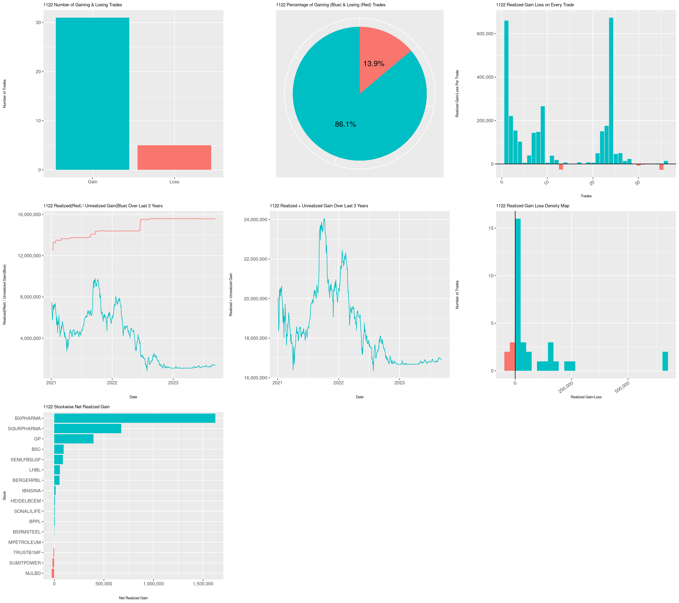

Next two charts in the same tab comes from ‘*Realized and Unrealized Gain Table*’, using the field TWRR. The chart in left plots TWRR against Date, and the chart on the right plots TWRR value at the end of every year.

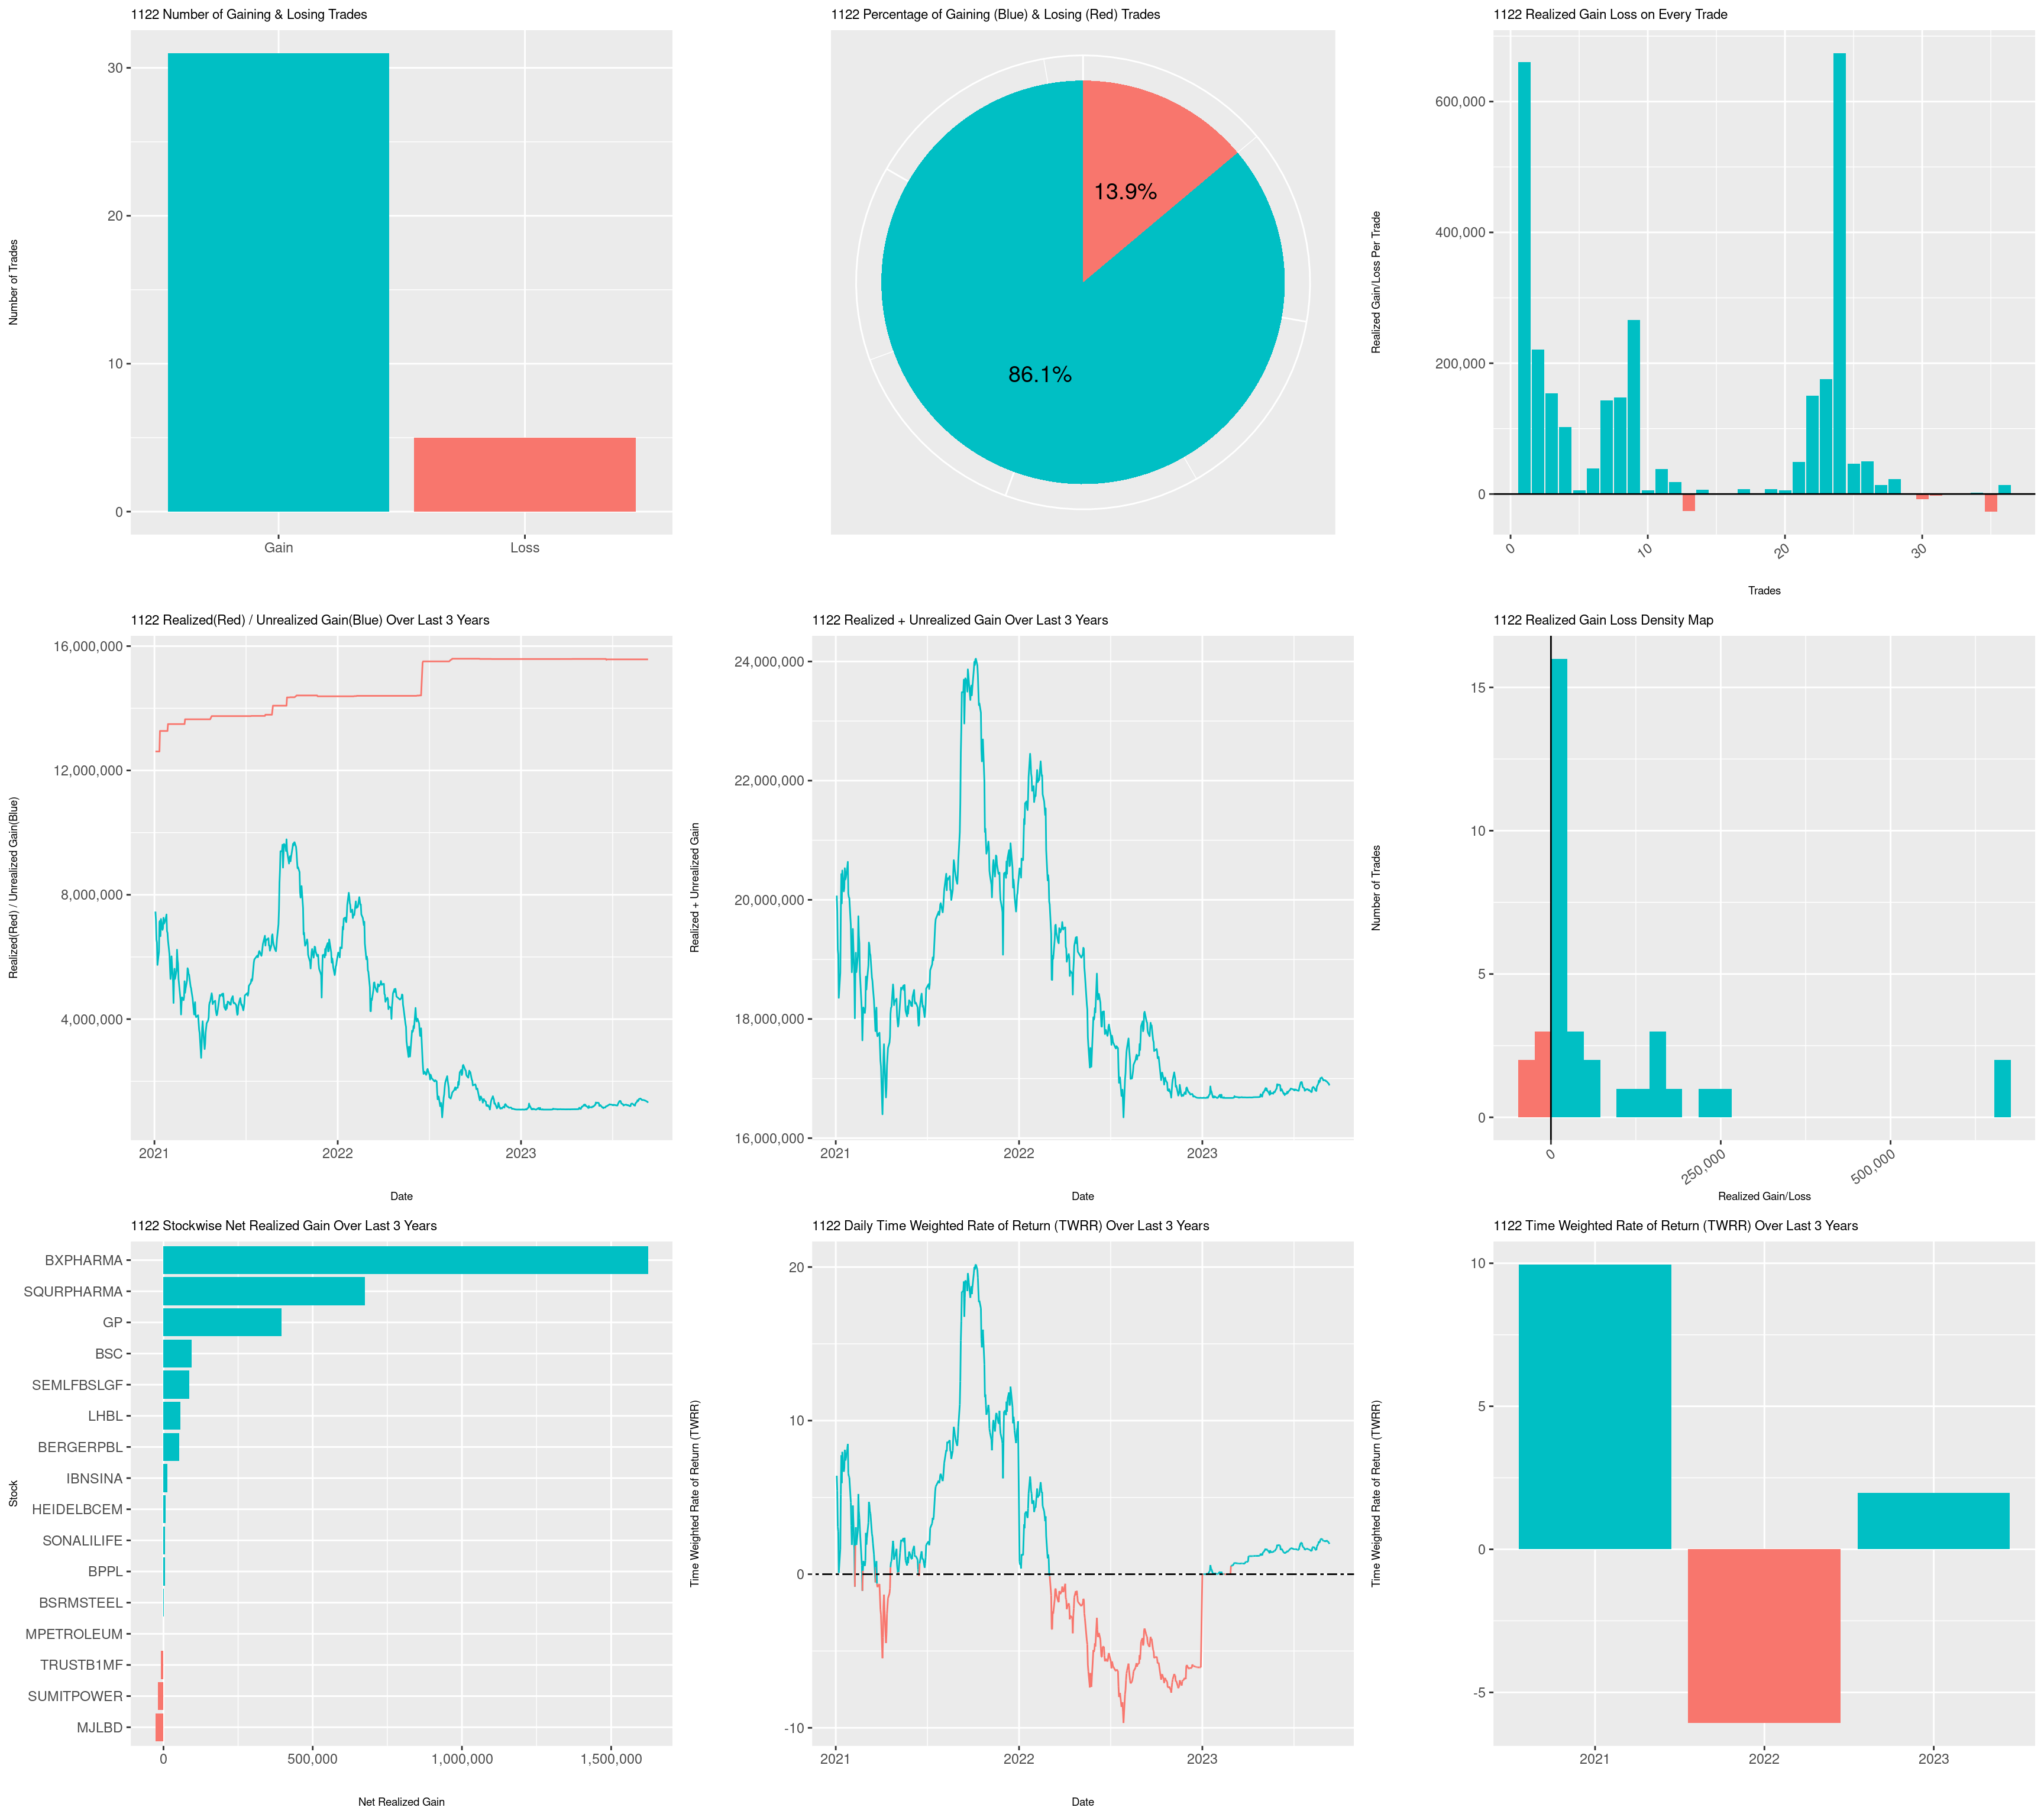

**Tab 2 : Stock wise Gain/Loss Summary**

This tab will show the stocks the client had in the portfolio in the given data range, and stock wise total gain / loss in that date range. Data for this table will come from ‘*Stock wise Gain/Loss Table*’.

|  |  |  |  |  |  |
| --- | --- | --- | --- | --- | --- |
| **Stock** | **Total Gain** | **Total Loss** | **Net Gain/(Loss)** | **Average Gain % Per Trade** | **Average Loss % Per Trade** |
| BXPHARMA | 2,000,000 | (500,000) | 1,500,000 | 10% | -5% |
| … | … | … | … | … | … |
| MJLBD | 0 | (50,000) | -50,000 | 10% | -5% |

The tab will also contain a diverging bar chart as per below example. The field used in the chart is ‘*Net_Gain*’ in ‘*Stock wise Gain/Loss Table*’. Then chart height will change as the number of stocks increases or decreases for different clients.

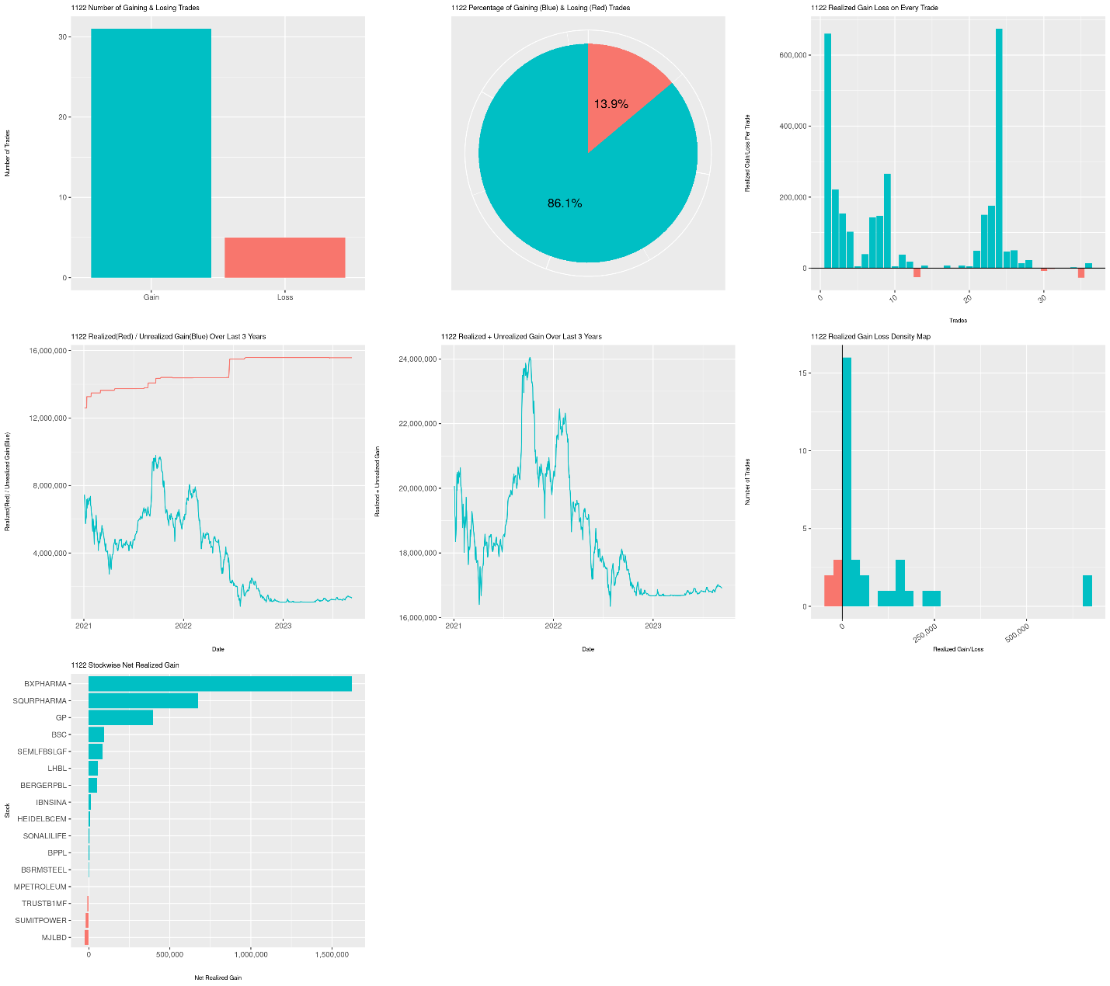

The next charts in the same tab will be two pie charts. The green chart on the left shows POSITIVE Net Gain Percentages from all the stocks that has positive Net Gain. And the Red chart on the right shows NEGATIVE Net Gain percentages from all the stocks that has negative Net Gain.

In both the chart, stocks with less than 10% values are GROUPED in “OTHER” category, to keep the pie chart neat in case of many stocks.

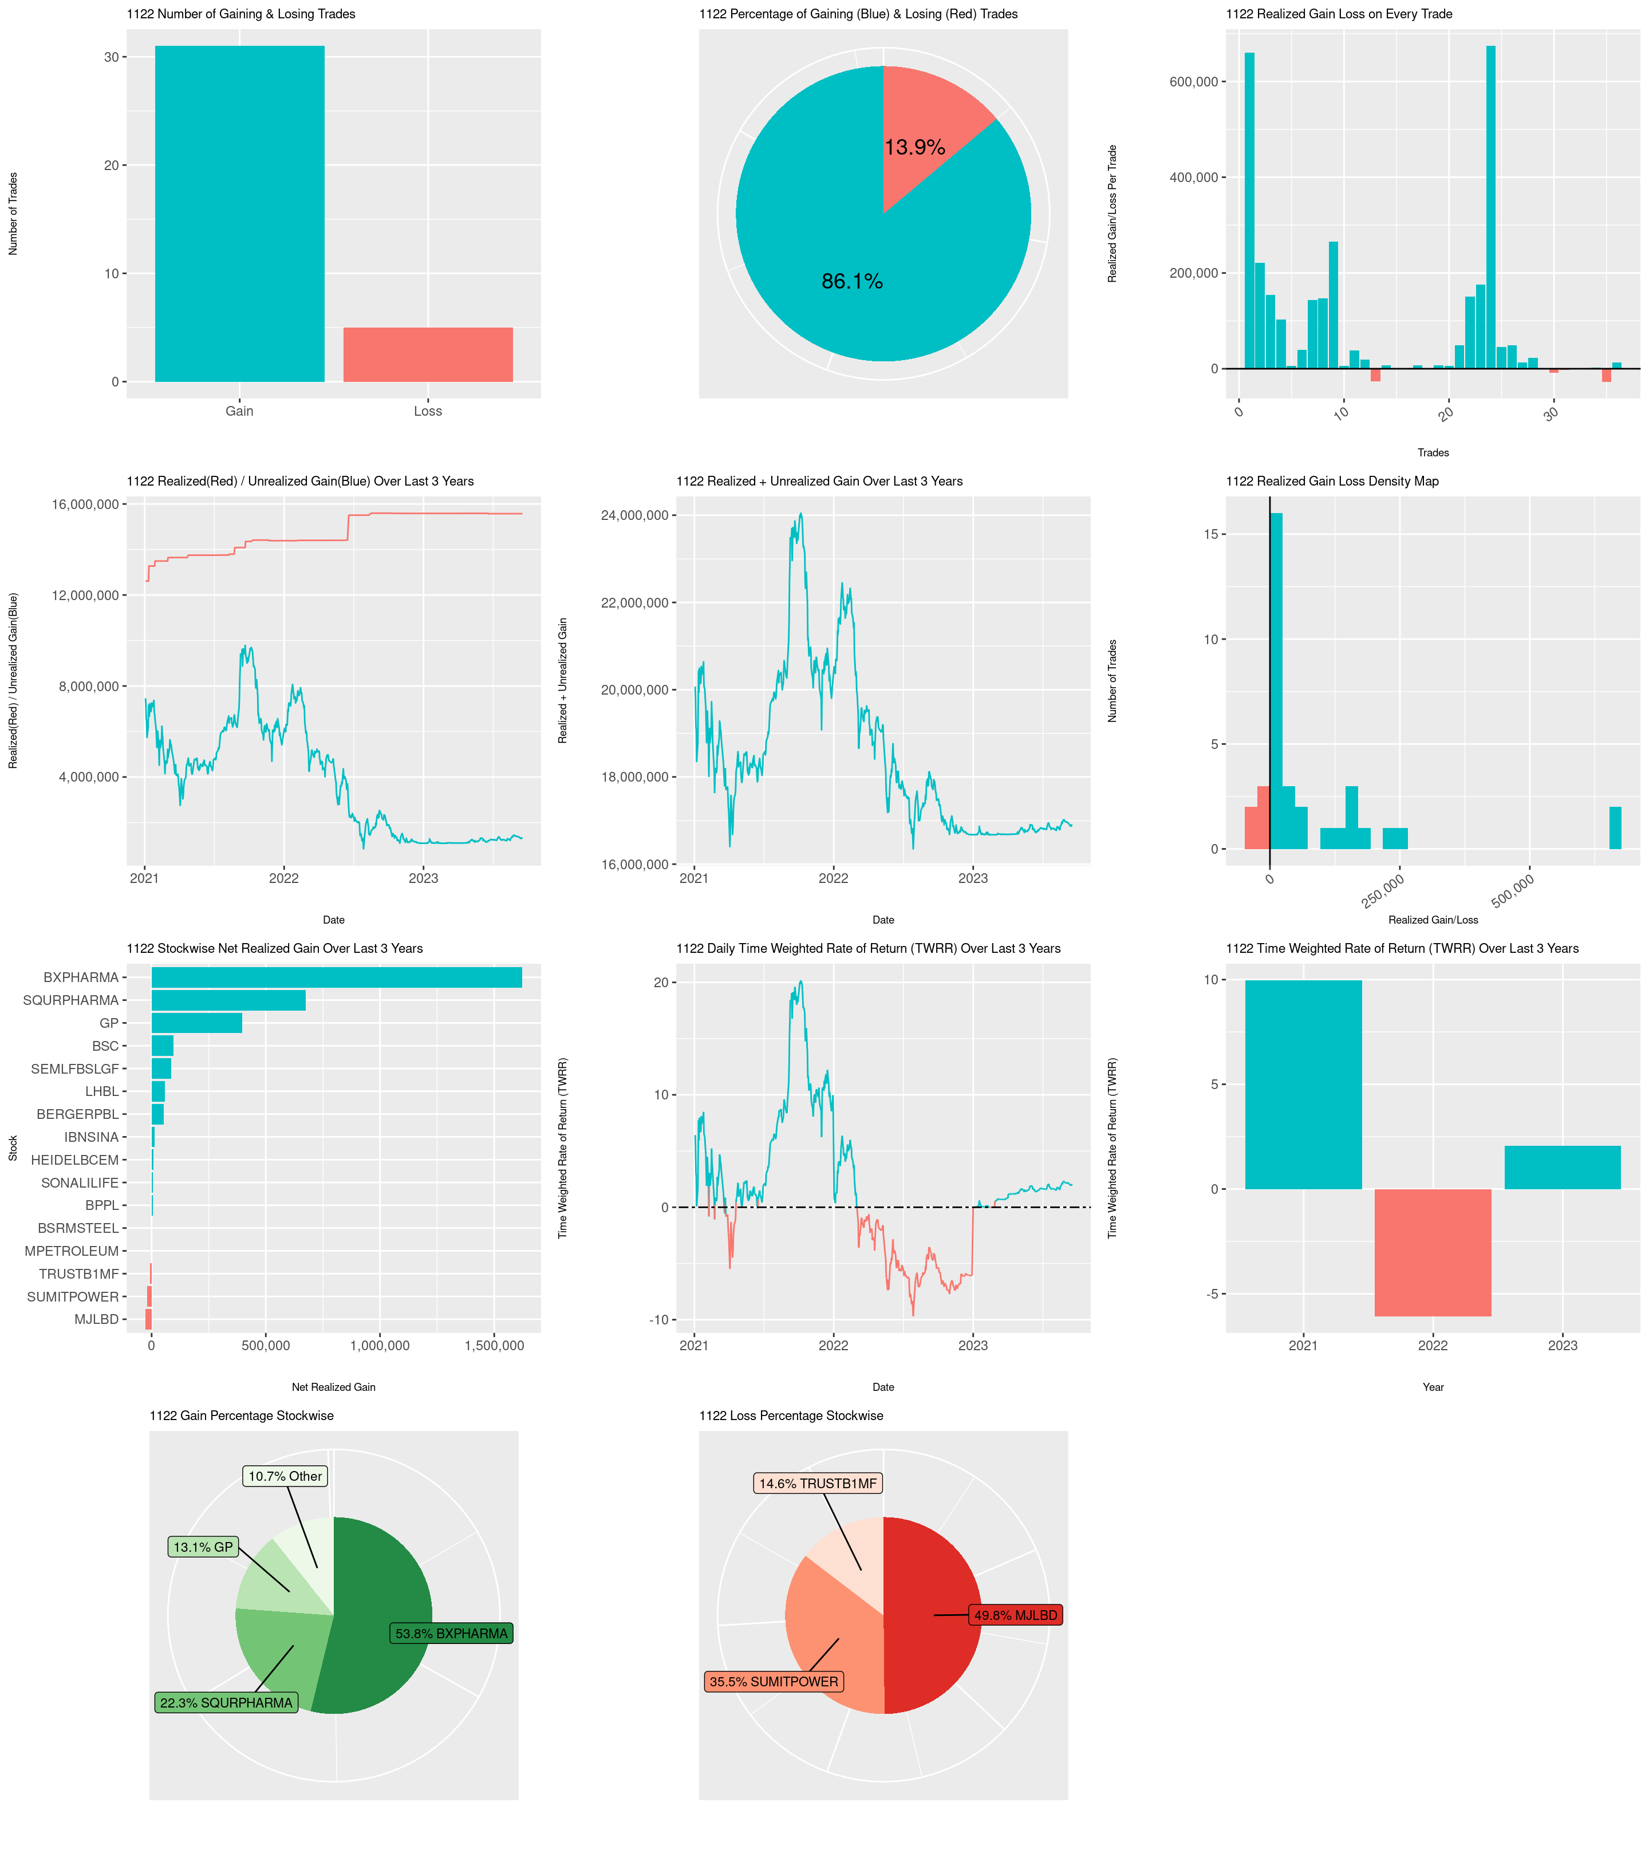

**Tab 3 : Daily Gain/(Loss) Heatmap**

This tab will show a calendar in the given date range. In the calendar, the days will be colored in green or red, where green represents the days the client had positive gains from trades, and the red represents the days the client had Loss from trades. The field ‘*Net_Gain*’ in the table ‘*Daily Gain/Loss Table for Heatmap*’ will be used for this heatmap.

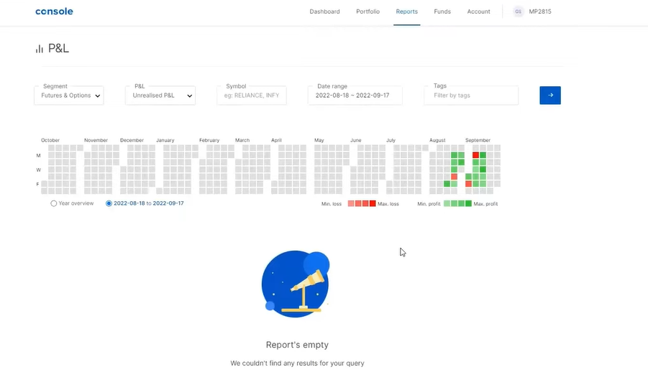

Example: Zerodha Gain & Loss Heatmap Calendar

**Tab 4 : Gain/Loss Trend**

The table will contain daywise realized and unrealized gain values. The source of this table will be ‘*Realized and Unrealized Gain Table*’ . The table will be **collapsed** initially, the user might want to expand the table to see the full long table.

|  |  |  |  |
| --- | --- | --- | --- |
| **Date** | **Realized Gain** | **Unrealized Gain** | **Realized + Unrealized Value** |
| 1-Jan-2021 | 1,000 | (50,000) | (49,000) |
| … | … | … | … |
| 8-Aug-2023 | 200,000 | (100,000) | 100,000 |

The tab will also contain line charts of the above variables as per example given below.

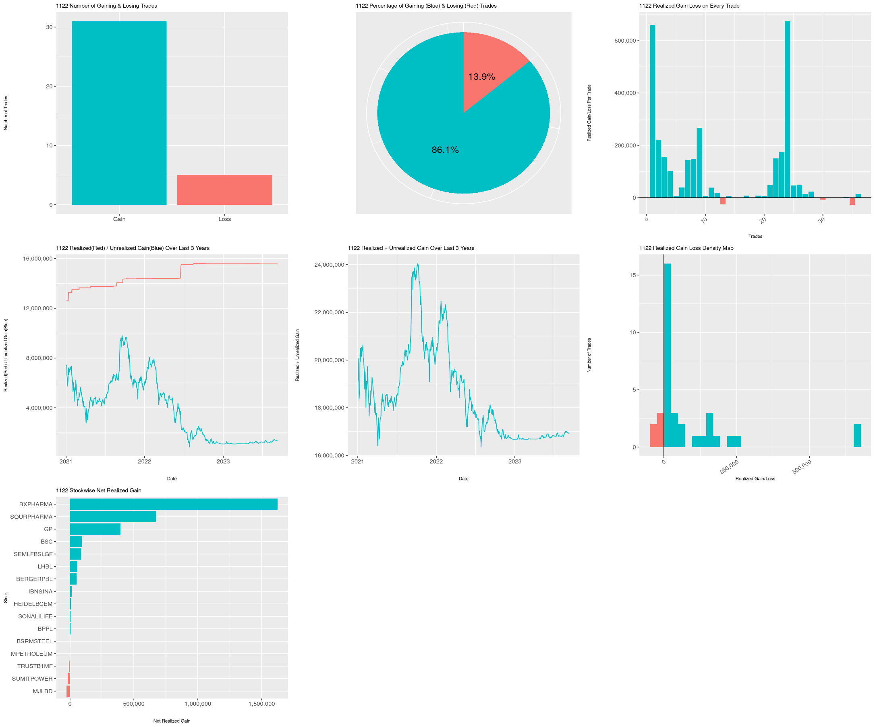

The same tab will contain the two charts as below. The data source of these charts is the ‘*Primary Data*’, and the field used will be ‘*Gain_Loss_SELLING*’.

Chart on the left shows realized gain/loss on every trade the client has made. The chart on the right is a histogram of the realized gain of the client. The green and red colors indicated positive and negative realized gains respectively.

